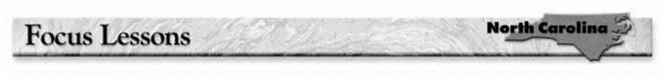

**Lesson 16: Evaluating the Credibility of a Passage**

**Evaluating the credibility of a passage** involves determining whether the passage is accurate and whether you can believe that the facts stated are true. To evaluate the credibility of a factual passage, look at the following:

* What is the **source** of the information? Can you determine if the source is an expert in this field? Are you told how the information was collected?
* What is the **evidence** backing up the facts? Are you given statistics, and are the source of the facts given?
* What is the **tone** of the passage? Is the tone informational? The passage should be neutral and unemotional.

**DIRECTIONS: *You are conducting research on which kinds of dogs are most popular in the United States. When surfing the Web, you come across this passage called “Survey Says.” As you read, look for indications of whether the passage is credible or not. Then answer the questions that follow.***



