Name: ___________________________
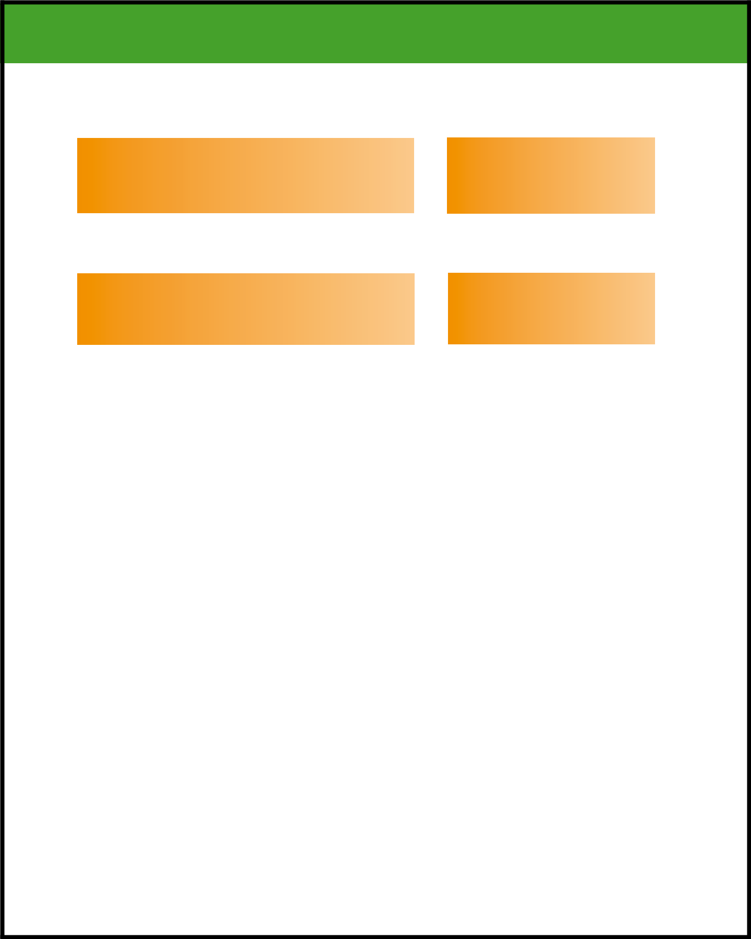

Dot, Dot, Dot: The Ellipsis

An ellipsis is a series of three dots (. . .) which shows that some text has been left out. The ellipsis is used to shorten a passage. The omitted text does not change the meaning of the original text and is unnecessary to its meaning.

Example with complete text: |  | Example with ellipsis:
The guests who visited the school on Thursday |  | The guests . . . were impressed
afternoon were impressed by the library. |  | by the library.

Note there is a space before and after the ellipsis. If the ellipsis comes at the end of a sentence, the ellipsis is followed by a space and a period.

Example with complete text: |  | Example with ellipsis:
The parade had clowns, floats and a brass band |  | The parade had clowns, floats
which wore blue uniforms. |  | and a brass band . . . .

Rewrite each sentence below omitting text and using an ellipsis.

- We were cautioned by the 8th grade World History teacher Mrs. Petersen not to run in the halls.

- The important point to make, and I cannot say it too often, is that music and art are important factors in a culture.

- He couldn’t run fast enough, although he tried with all his might, to catch the carriage as it traveled down the road.

- When we think about it carefully, and we should be careful to think about it, the use of punctuation is a science and an art.

- The children played on all the playground equipment including the swings, the slide, the monkey bars, and the merry-go-round.

